**CAPSTONE PROJECT SYNOPSIS**

**Pneumonia detection**

**Table of Contents**

**CHAPTER 1: INTRODUCTION** ........................................................................................... 1.1.Title & Objective of the study ........................................................................................... 6 1.2 Need of the Study................................................................................................................ 6 1.3 Data Sources........................................................................................................................ 6 1.4 Attributes Information....................................................................................................... 6 1.5. Tools & Techniques........................................................................................................... 6

CHAPTER 2: DATA PREPARATION.................................................................................. 2.1 Phase I – Image Extraction and Cleaning .......................................................................... 7 2.2. Resizing the images ...........................................................................................................7 2.3. Preprocessing and training ..................................................................................................8

**CHAPTER 3: MODEL BUILDING**

3.1. Data augmentation..............................................................................................................8

3.2. Summary of model……………………………………………………………………….9

3.3.Visualization……………………………………………………………………………..11

3.4.Precision vs recall………………………………………………………………………..15

3.5.Confusion matrix ..............................................................................................................16

**CHAPTER 4: CONCLUSION**

4.1. Results of sample images…………..……………………………………………………17

**CHAPTER 1: INTRODUCTION**

* 1. **Title & Objective of the study:**

“Pneumonia detection” is the project title and objective is to classify the chest X rays as Pneumonia or normal.  Statistical results obtained demonstrates that pretrained CNN models employed along with supervised classifier algorithms can be very beneficial in analyzing chest X-ray images, specifically to detect Pneumonia.

**1.2 Need of the Study**

**Chest X-Rays** which are used to diagnose pneumonia need expert radiotherapists for evaluation. ... Statistical results obtained demonstrates that pretrained CNN models employed along with supervised classifier algorithms can be very beneficial in analyzing chest X-ray images, specifically to detect Pneumonia.

Within Deep Learning, **a Convolutional Neural Network** or CNN is a type of artificial neural network, which is widely used for image/object recognition and classification. As CNNs are playing a significant role in these fast-growing and emerging areas, they are very popular in Deep Learning.

**1.3 Data Sources**

The Dataset contains chest Xray images split for test, train and validation purpose.

**https://www.kaggle.com/**

**1.4 Attributes Information:**

The Dataset contains 5856 Xray images.

**1.5. Tools & Techniques: Tools: Google Colab.**

Techniques: tensorflow using keras,optimizers,splitting train and test data,obtaining results.

**CHAPTER 2: DATA PREPARATION**

**2.1 Phase I – Image Extraction :**

At first let us import the necessary Libraries that we need for computation and processing

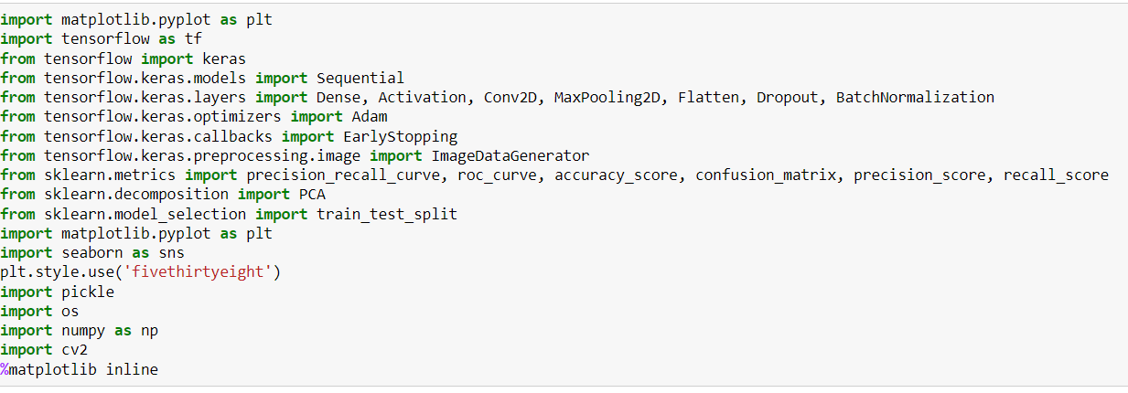

The Dataset contains 5856 Xray images ,split for training, testing and validation.

**2.2.Resizing the images**

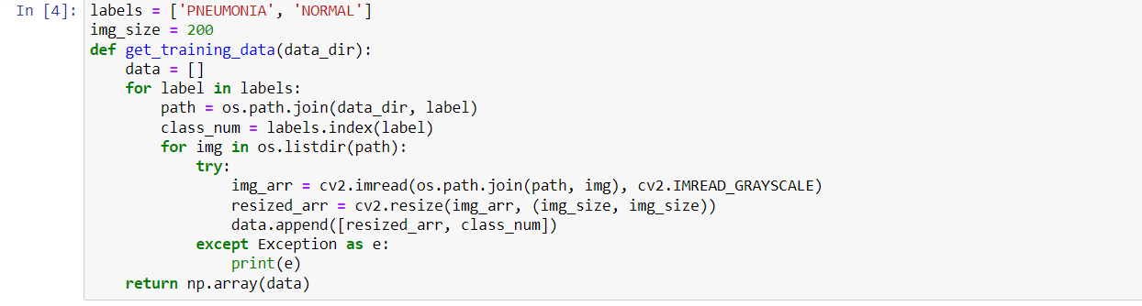

**2.3. Preprocessing and training of Images:**

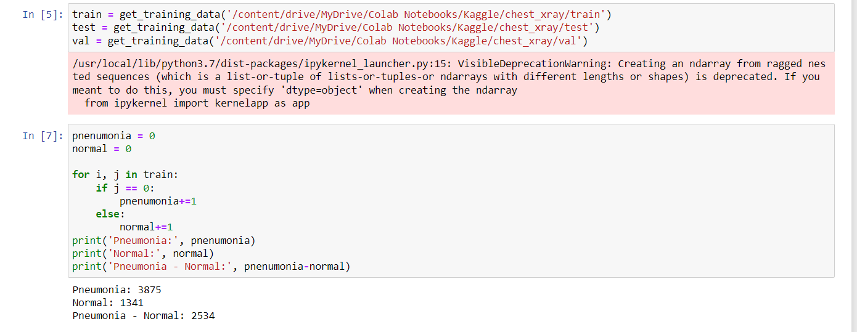

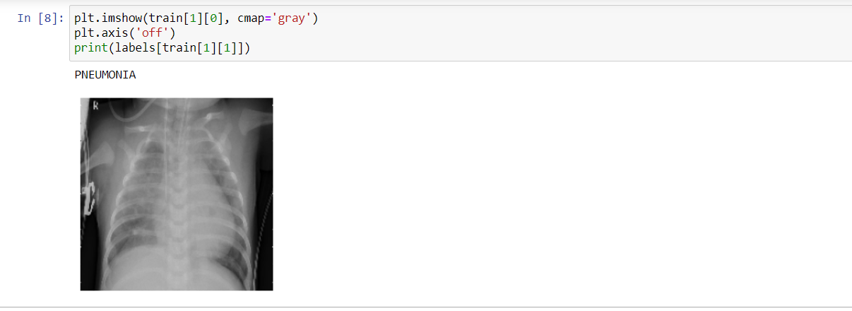

**CHAPTER 3: MODEL BUILDING**

**3.1. Data Augmentation :**

Labeling of data

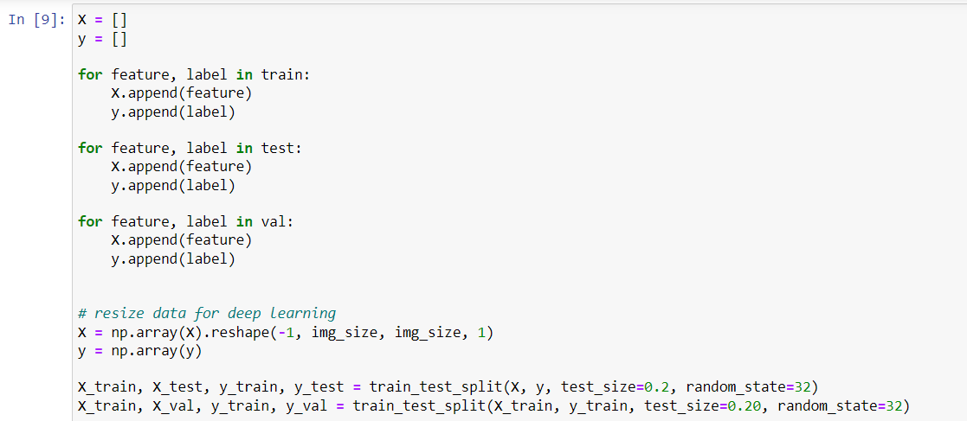

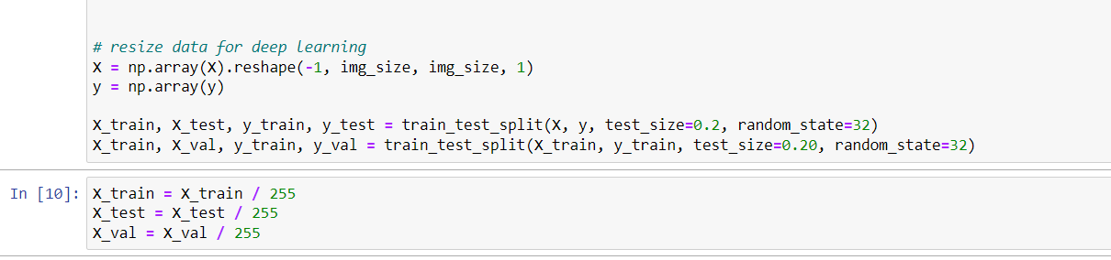

**3.2. Summary of model:**

Using ImageDataGenerator and fitting the same

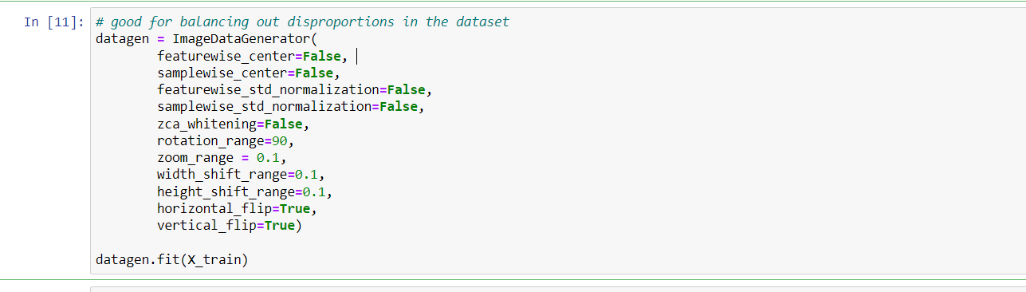

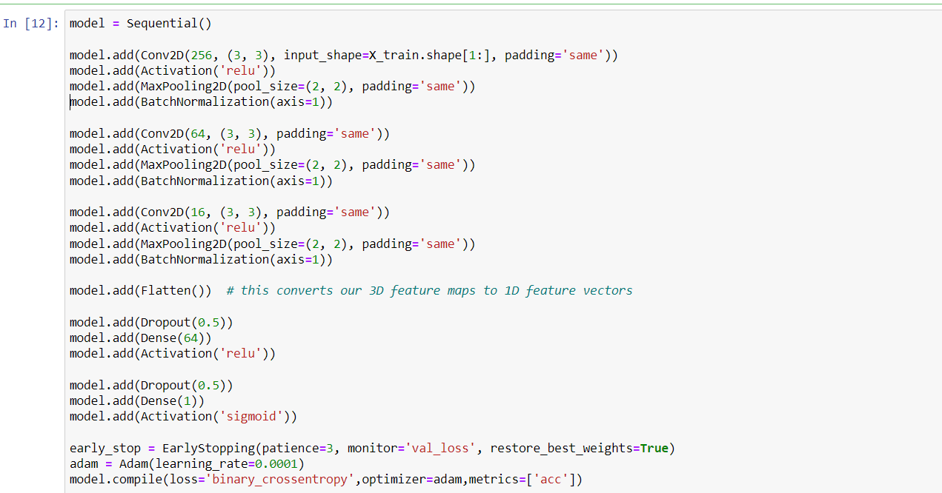

**Summary**

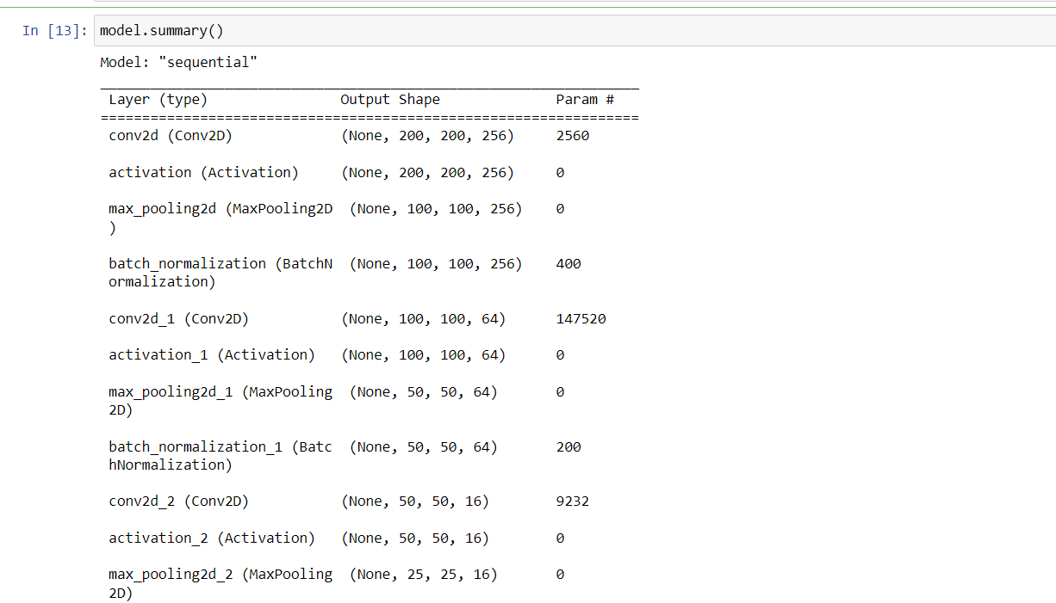

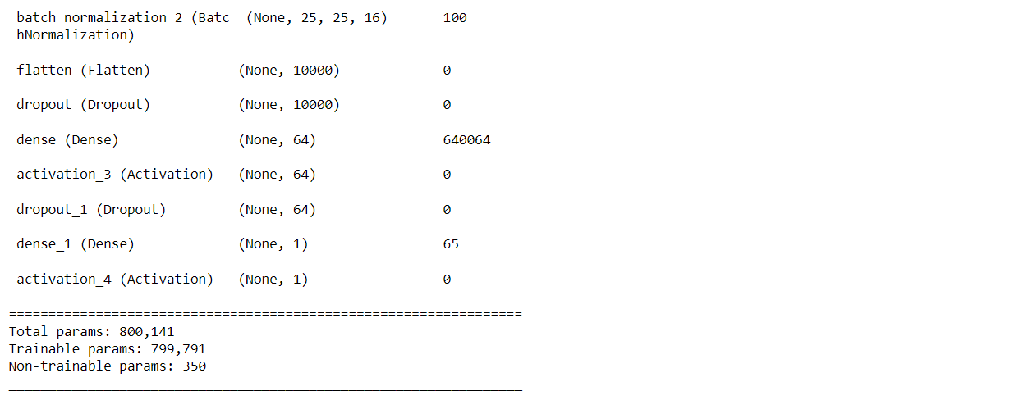

**Fitting of the model**

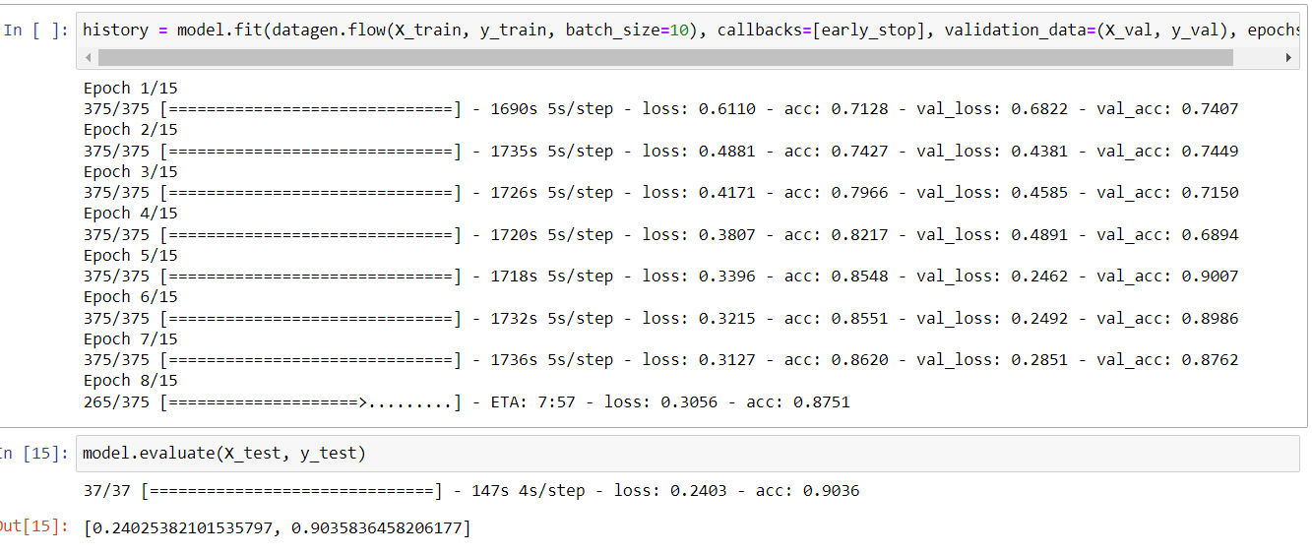

**3.3.Visualization**

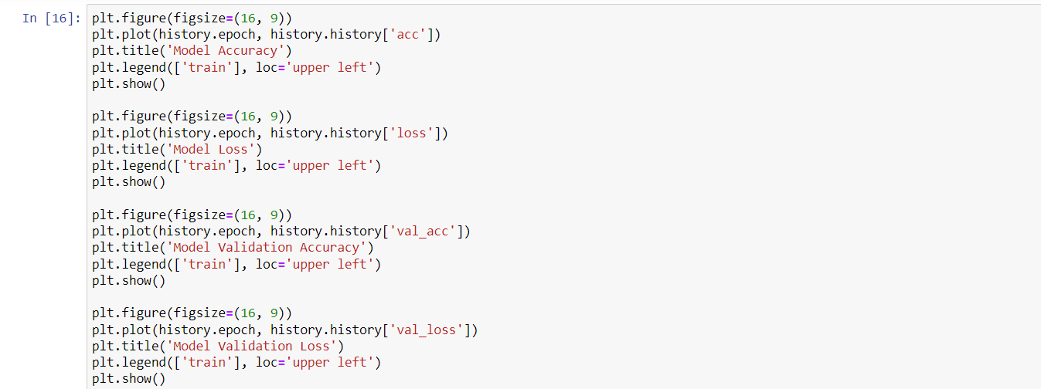

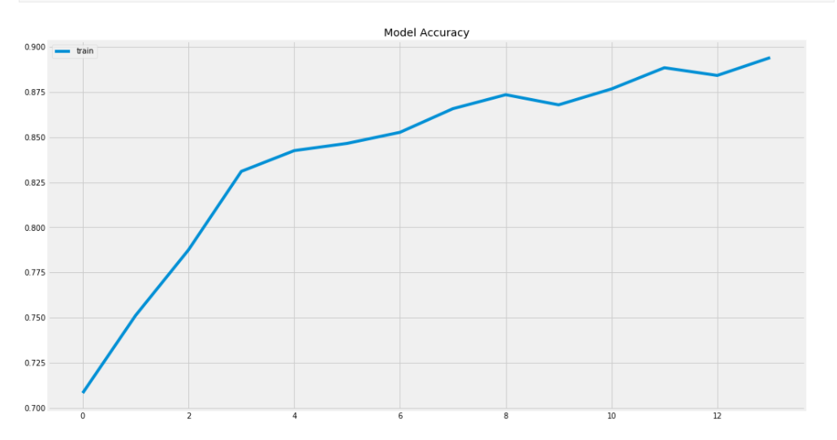

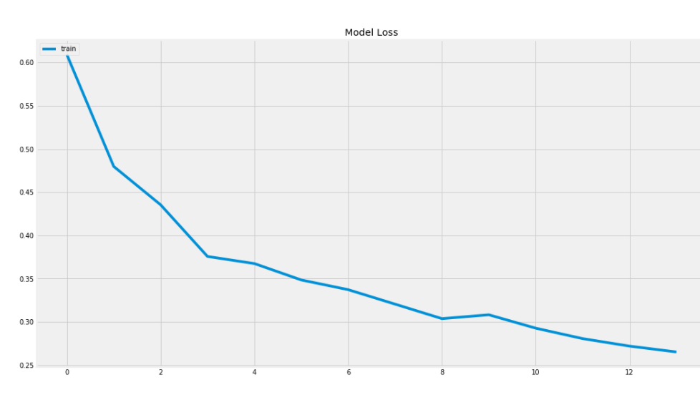

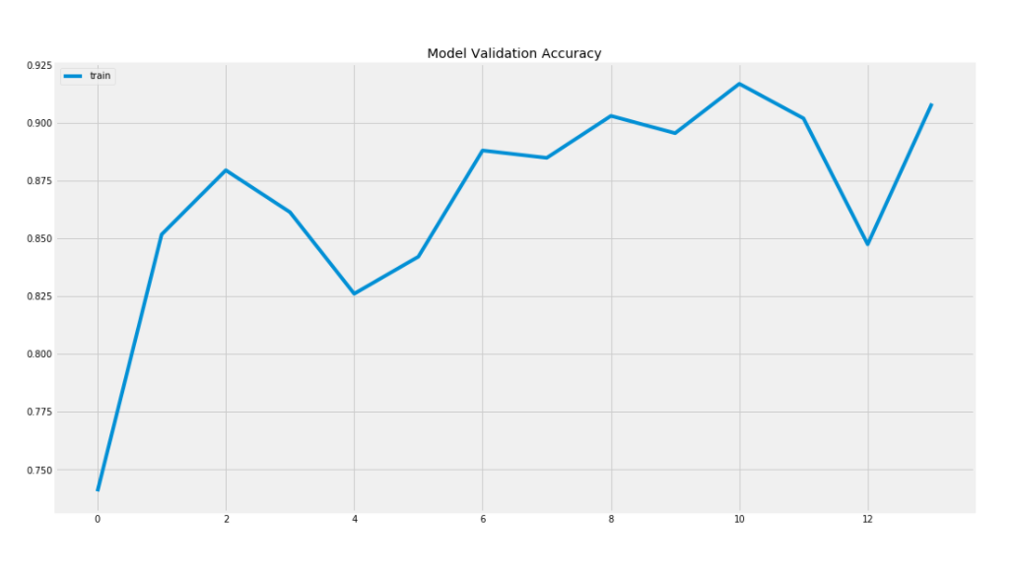

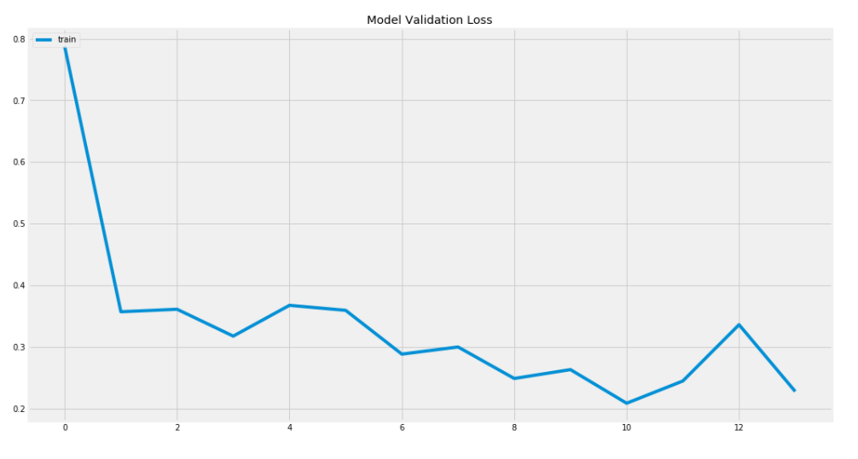

**3.4. Precision Vs recall:**

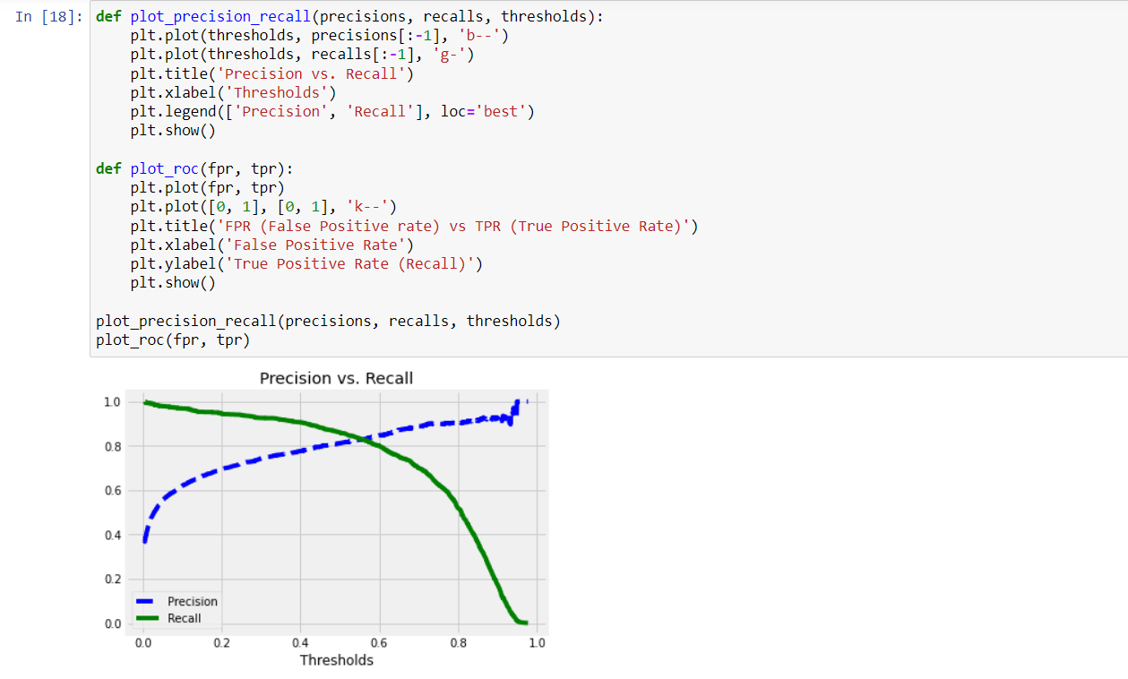

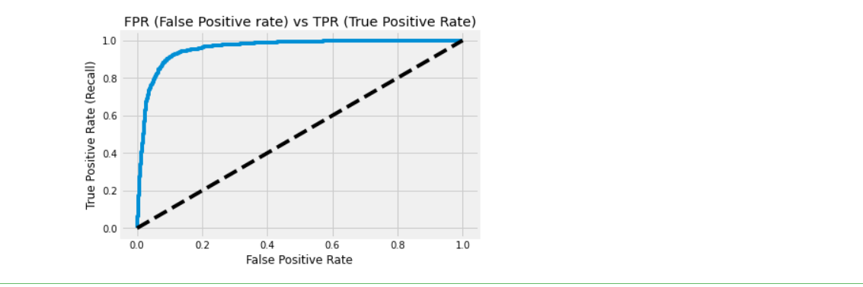

The predictions show that accuracy on testing set is 90% it also shows the precision and recall ratio on the testing set.

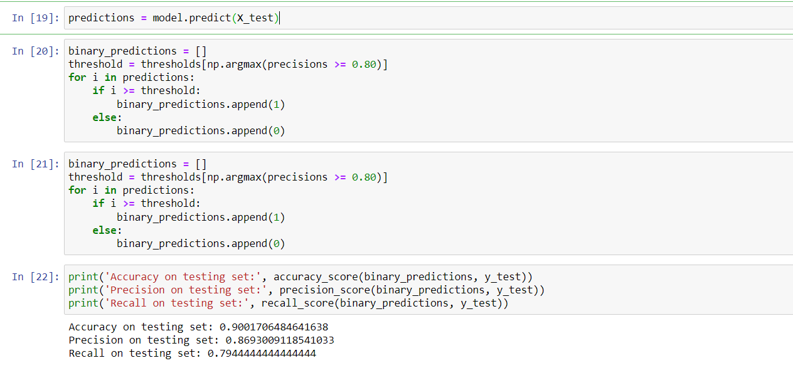

**3.4. Precision Vs recall:**

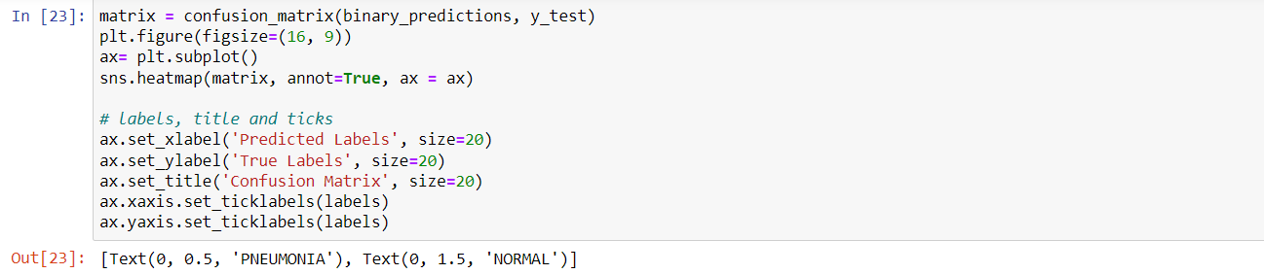

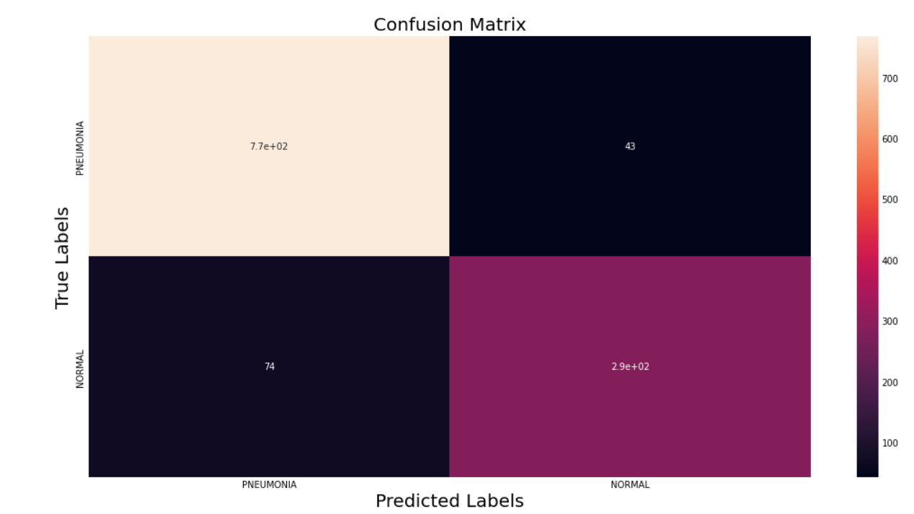

**CHAPTER: 4.CONCLUSION**

**4.1. Results:**

Showing results of 25 sample images,

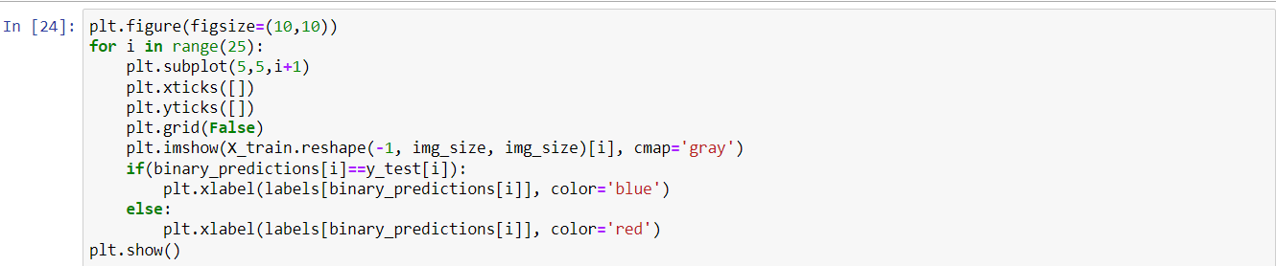

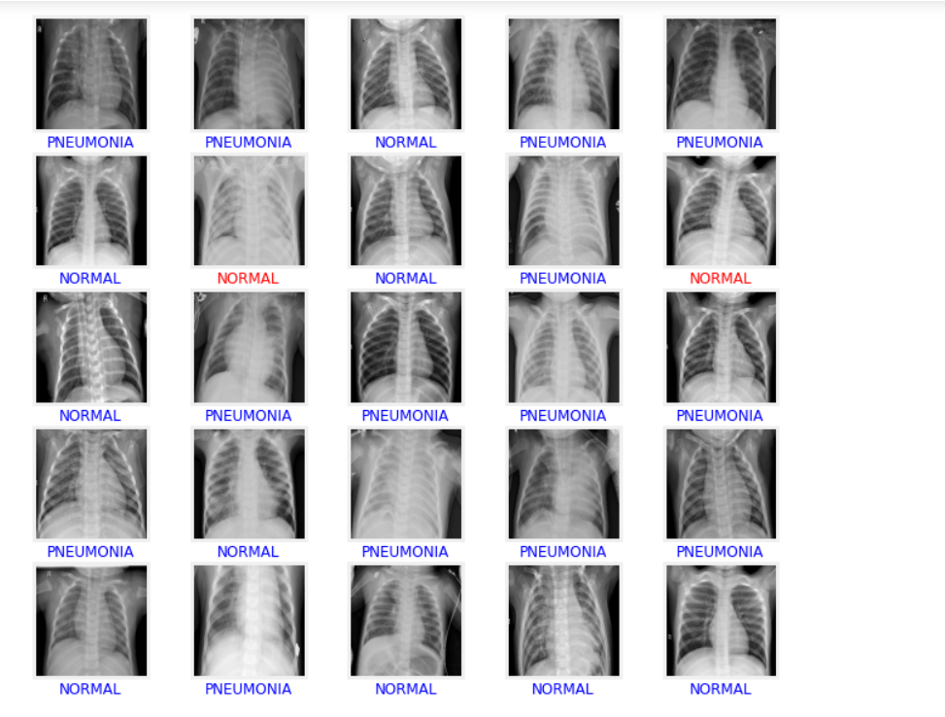

This project will provide an overview of how to build an model from scratch to detect

Pneumonia using Tensorflow and Keras. This mini-project allows a beginner to obtain an overview of how to build a model to solve a real-world problem.